**Who Are Managers? Where Do They Work?**

* Organization
  + Two or more people who work together in a structured way to achieve a goal or a set of goals.
* Goal
  + The purpose that an organization strives to achieve. Goals are fundamental elements of organization
* Common Characteristics of Organizations
  + Distinct purpose
  + People working together
  + A deliberate systematic structure

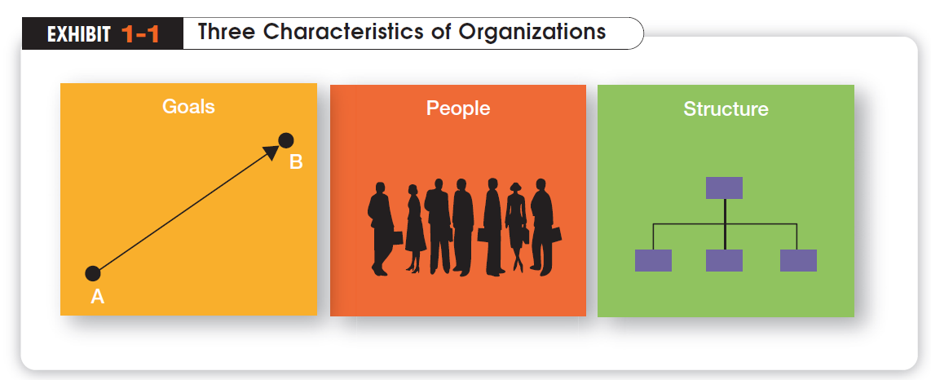

**How are Managers Different from Non-managerial Employees?**

* Non-managerial Employees
  + People who work directly on a job or task and have no responsibility for overseeing the work of others. Ex: associates, team members
* Managers
  + Individuals in organizations who are responsible for directing the efforts and activities of others aimed at helping organizations achieve their goals.

**What is Management?**

* Management
  + The *process* of getting things done *effectively* and *efficiently*, with and through people
  + The process of planning organizing leading and controlling the work of organization members and of using all available organizational resources to reach stated organizational goals
* Effectiveness
  + “Doing the right thing”, doing those tasks that help an organization reach its goals
* Efficiency
  + “Doing things right”. Concerned with the means, efficient use of resources like people, money, and equipment

**Four Management Functions**

Henri Fayol, a French industrialist in the early twentieth century, proposed that all managers perform five management activities: plan, organize, command, coordinate and control. Today these management functions have been condensed to four.

* Planning
  + Defining the organizational purpose and ways to achieve it
  + The process of establishing goals and a suitable course of action for achieving those goals
* Organizing
  + The process of engaging two or more people in working together in a structured way to achieve a specific goal or a set goals
* Leading
  + The process of directing and influencing the task-related activities of group members or an entire organization
* Controlling
  + The process of ensuring that actual activities conform to planned activities
  + Monitoring, comparing, and correcting work performance

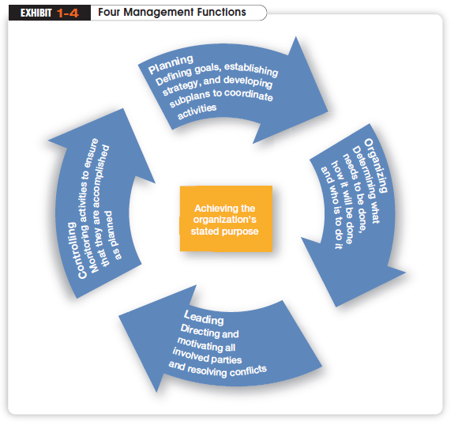

**What Roles Do Managers Play?**

In the 1960s, Henry Mintzberg did an empirical study of chief executives and discovered that managers were engaged in a number of varied, un-patterned, and short-duration activities. He defined management by categorizing what managers do based on the managerial roles they perform at work. Henry Mintzberg observed that a manager’s job can be described by ten roles performed by managers in three general categories

* Interpersonal Roles
  + Figurehead, Leader, and Liaison
* Informational Roles
  + Monitor, Disseminator and Spokesperson
* Decisional roles
  + Entrepreneur, Disturbance Handler, Resource Allocator and Negotiator

**Types of Managers**

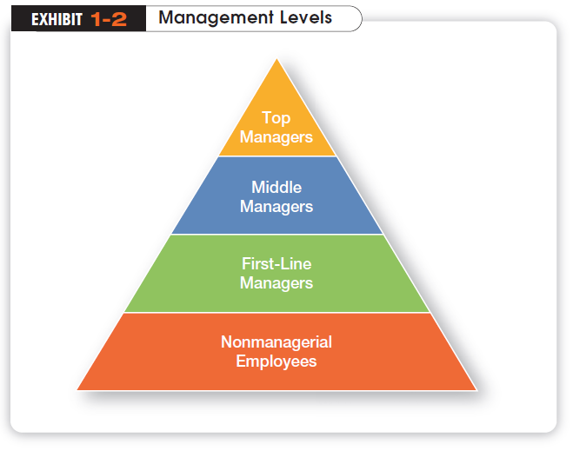

***Management Level***

* Top Managers
  + Responsible for making decisions about the direction of the organization.
  + Examples; President, Chief Executive Officer, Vice-President
* Middle Managers
  + Manage the activities of other managers.
  + Examples; District Manager, Division Manager
* First-line Managers
  + Responsible for directing nonmanagerial employees
  + Examples; Supervisor, Team Leader

***Functional and General Managers***

* Function Managers
  + The functional manager is responsible for only one functional area or organizational activity, such as production, marketing or finance
* General Managers
  + The general manager is responsible for all functional activities for an organization; and oversees a complex unit, such as a company, a subsidiary or an independent operating division. Ex. President, Chief Executive Officer

**What Skills Do Managers Need?**

Henry Fayol identified three basic kinds of skills

* Conceptual Skills
  + The ability to coordinate and integrate all of an organization’s interests and activities
* Interpersonal/Human Skills
  + The ability work with, understand and motivate other people as individuals or in groups. Ex. communicate, motivate, mentor and delegate
* Technical Skills
  + The ability to use the procedures, techniques, and knowledge of a specialized field. Based on specialized knowledge required for work

|  |  |  |  |  |  |  |  |
| --- | --- | --- | --- | --- | --- | --- | --- |
| **Top Management** | **Conceptual Skill** | | |  | | |  |
| **Middle Management** |  | | **Human Skill** | | |  | |
| **First-line Management** |  |  | | | **Technical Skill** | | |

Figure: Relative skills needed for effective performance at different levels of management

The challenges of Management

* The need for Vision
  + Ex. New Technologies
* The need for Ethics
  + Ex. Industrial pollution
* The need for Responsiveness to cultural Diversity
  + Ex. Have to handle people from different cultures