**1890 1900 1910 1920 1930 1940 1950 1960 1970 1980 1990 2000 2010**

**Scientific Management School**

**Classical Organizational Theory School**

**Behavioral School**

**Management Science School**

**The Systems Approach**

**The Contingency Approach**

**Dynamic Engagement Approach**

Figure: Management Theories (an overview)

**The Scientific Management School**

It arose in the need to increase productivity. Skilled labor was short at the beginning of twentieth century. The only way to expand productivity was to raise the efficiency of worker.

***Frederick W. Taylor:*** Four basic principles:

1. The development of a true science of management

2. The Scientific selection of workers

3. The scientific education and development of the worker

4. Intimate, friendly co-operation between management and labor

Using product line **Time Study** he broke each job down into its component and designed the quickest and best method of performing each component. He also encouraged employers to pay more productive workers at a higher rate than others. It is called the **differential rate system.**

* **Limitations**
  + Working harder and faster would exhaust whatever work available.
  + Pressure on employee to work faster
  + More worker joined unions and mistrust and suspicion is reinforced.

***Henry L. Gantt:*** Worked with Taylor. Gantt began to reconsider Taylor’s incentive system, abandon the differential rate system. His new idea was as follows:

Every worker who finished a day’s assigned work load would win a 50-cent bonus. The **supervisor would earn a bonus** for each worker who reached the daily standard, plus an extra bonus if all workers reached it. Every worker’s progress was rated publicly and recorded on individual bar chart. Other contribution: **Gantt chart**

***Frank & Lillian Gilbreth:***

* Contributed to the scientific management movement as a husband and wife team.
* In their conception motion and fatigue were intertwined. Every motion that was eliminated reduced fatigue.
* Used motion picture camera to find most economical motion for each task to upgrade performance and reduce fatigue
* Aim was to help workers to reach their full potential as human beings.

**Classical Organization Theory School**

***Henri Fayol:*** Identified 14 management principles

* 1. **Division of labor:** Jobs can have too much specialization leading to poor quality and worker dissatisfaction
  2. **Authority:** Included both formal and informal authority resulting from special expertise
  3. **Discipline:** Obedient, applied, respectful employees are necessary for the organization to function.
  4. **Unity of command:** Employees should have only one boss
  5. **Unity of direction**: A single plan of action to guide the organization
  6. **Subordination of individual interest to the common good:** The interest of the organization takes precedence over that of the individual employee
  7. **Remuneration:** An equitable uniform payment system that motivates contributes to organizational success
  8. **Proper Centralization:** The degree to which authority rests at the top of the organization
  9. **Hierarchy:** A clear chain of command from top to bottom of the firm
  10. **Order:** Material and people should be in the right place at the right time
  11. **Equity or Fairness:** The provision of justice and the fair and impartial treatment of all
  12. **Stability of staff:** Long-term employment is important for the development of skills
  13. **Initiatives:** The promotion of creativity and innovation by encouraging employees to act on their own
  14. **Esprit de corps:** Promoting team spirit will give the organization a sense of unity.

***Max Weber:*** Considered the ideal organization be **Bureaucratic**. Stressed for a strictly defined hierarchies governed by clearly defined regulations and line of authority. Performance evaluations should merit basis.

***Mary Parker Follett:*** Follett was convinced that no one could become a whole person except as a member of a group; **human being grew through their relationship with others in organization**. She took for granted Taylor’s assertion that labor and management shared a common purpose as members of the same organization, but she believed that the artificial distinction between managers (order givers) and subordinates (order takers) obscured this natural partnership. She was a great believer in the **power of the group**, where individuals could combine their diverse talents into something bigger.

***Chester I. Barnard:*** People who come together in formal organizations to achieve ends they can not accomplish working alone. But as they pursue the **organization’s goal**, they **must also satisfy their individual needs**. So, an enterprise can operate efficiently and survive only when the organization’s goal are kept in balance with the airs and needs of the individuals working for it.

Barnard believed that individual and organizational purposes could be kept in balance if managers understood an employee’s **zone of indifference –** that is, what the employee would do without questioning the manager’s authority.

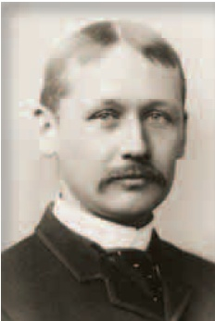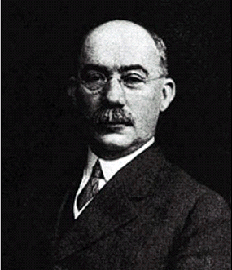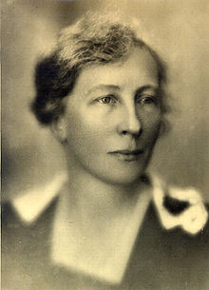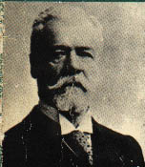

**Frederick W. Taylor Henry L. Gantt Lillian Gilbreth Henri Fayol**

**The Behavioral School**

The ***Hawthrone Experiment:*** Studies was conducted at Western Electric Company near Chicago from 1924 to 1933 by Elton Mayo and his colleagues. The study began as an attempt to investigate the relationship between the level of lighting in the workplace and worker productivity. But this experiment provided new insights into individual and group behavior in the behavior of people at work. Employees work harder if they believe management is concerned about their welfare, or simply if they receive social attention.

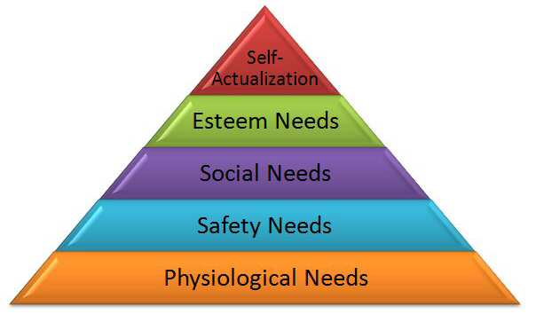***Maslaw’s Need Theory:*** Needs that people are motivated to satisfy fall into a hierarchy. Lower level need must be satisfied before higher level need is met.

***McGregor’s Theory:*** Distinguished two basic assumptions about people and their approach to work.

*Theory X* Manager assumed that people must constantly be motivated to do their work, they dislike work; they must be motivated by force, money or praise.

*Theory Y* managers assume that, people are eagerly approach their work and opportunity to develop their creative capacity.

**Management Science School**

Quantitative techniques (Operations Research) were used to improve decision making. It was evolved from mathematical and statistical solutions developed for military problems during World War II. The management science school gained popularity through two postwar phenomena. **First,** the development of high-speed computers and of communications among computers provided the means for tackling complex and large-scale organizational problems. **Second,** Robert McNamara implemented a management science approach at Ford Motor Company in the 1950s and 1960s. On the other hand, W. Edwards Deming and Joseph M. Duran ‘s ideas became the basis for total quality management (TQM) .

**Recent Developments in Management Theories**

***Contingency Approach:*** or Situational approach. A recent approach seeks to integrate the various schools of management thought by focusing on the interdependence of the many factors involved in the managerial situation. **Fred Feildler** first popularized the contingency approach which says that organizations, employees, and situations are different and require different ways of managing. According to this approach, the manager’s task is to identify which technique will in a particular situation, under particular substances and at a particular time will contribute to the attainment of organization goals.

***The Systems Approach:*** View of the organization as a unified, directed system of interrelated parts. The point of the systems approach is that managers cannot function wholly within the confines of the traditional organization chart. They must mesh their department with the whole enterprise.

External Environment

**Transformation or conversion process**

Output Goods Services or Others

Input (*resources)*

Human

Capital (*Land, Equipment*

*Building)*

Technology

Information

Feedback

*Some Key Concepts:*

Subsystems, Open and closed

system, System boundary, Flows,

Feedback, Synergy.

***Dynamic Engagement Approach:*** Dynamic implies continuous change, growth and activity; engagement implies intense involvement with others. So, dynamic engagement best expresses the vigorous way today’s managers focus on human relationships and quickly adjust to changing conditions over time. Six different themes about management theory are emerging under the umbrella that we call dynamic engagement. These are, New organizational environments, Ethics and Social Responsiveness, Globalization and management, Inventing and reinventing organizations, Cultures and multiculturalism, Quality.