**What is Organization?**

* **Organization** is a pattern of relationship-many interwoven, simultaneous relationships through which people, under the direction of managers, pursue their common goals.
* **Organizational structure** is a framework that managers devise for dividing, organizing and coordinating the activities of members of an organization.

**Four building blocks of an Organization**

* Division of labor
  + Divide the total workload into tasks that can logically or comfortably be performed by individual or group. It means breaking the total job into small, simple, separate operation in which different worker could specialize.
* Departmentalization
  + It is the grouping of employees and tasks.
  + Professors are grouped into department in university
* Hierarchy
  + Once work is divided, departments created and span of management chosen, managers can decide on ***Chain of command***- a plan of who reports to whom.
* Coordination
  + Setup mechanism for integrating departmental activities.
  + Extent of coordination depends on the:
    - Nature of task performed
    - The degree of interdependence of people in various department performing them.

**Span of management Control**

The ***span of management control*** refers to the number of people and departments that report directly to a manager.

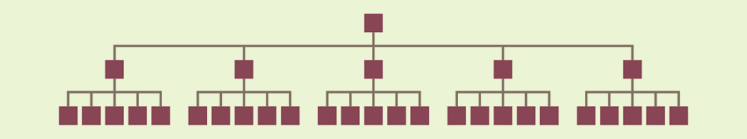Flat hierarchy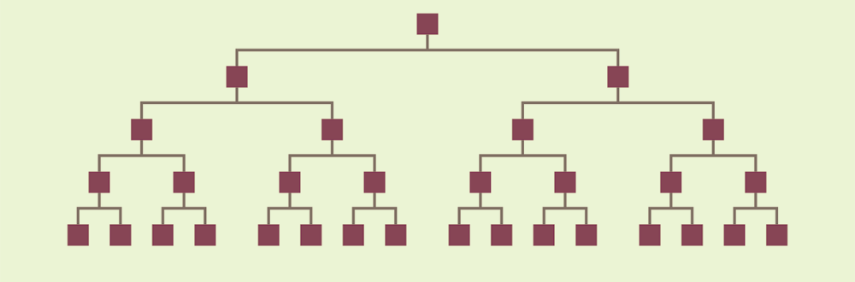 Tall hierarchy

Choosing an appropriate span of management control for an organizational hierarchy is important for two reasons: First: Too wide a span may mean that managers are overextended and employees are receiving too little guidance or control. Second: The span can affect the speed of decision making in situations where multiple levels in the organizational hierarchy are necessarily involved

**Organizational design**

Organizational design is the decision-making process by which managers choose an organizational structure appropriate to the strategy for the organization and the environment in which members of the organization carry out strategy.

Keep two things in mind.

* + First, because both strategies and environments change over time, organizational design is an ongoing process.
  + Second, changes in structure usually involve trial and error.

**Organizational design approaches**

**The Classical approach**

Max weber, Fredrich taylor and henry fayol, they believed that the most efficient and effective organization had

* + - A rigid hierarchical structure
    - Strong management
    - Bureaucracy

**Task technology approach**

The “Task Technology” refers to different kind of production technology for different type of products. Joan Woodward and her colleagues found that an organization’s task technology affected both its structure and its success. Woodward’s team divided about 100 British companies into three groups,

* + Unit and small batch production
    - * Refers to products made in small quantities in separate stages, such as machine parts that are later assembled
  + Large batch and mass production
    - * Refers to Large quantities of products often on an assembly line
  + Process production
    - * production of materials that are sold by weight

Woodward’s study leads to three general conclusions.

* + - The more complex the technology (from unit to process), the greater the number of managers and managerial levels.
    - The span of management for first level managers (Supervisors) increases from unit to mass production.
    - As, firms technological complexity increases, its clerical and administrative staffs become larger because managers need help with paperwork and non-production related work so they can concentrate on specialized tasks

**The Environmental approach**

Burns and Stalker distinguished between two organizational systems

* Mechanistic system
  + Management follow the classical bureaucratic chain of command
  + Best suited for stable environment (Armed force). In stable environment, each member is likely to continue performing the same task.
* Organic system
  + Individuals more likely to work in groups
  + Best suited for turbulent environment (Ad firm). In turbulent environment jobs must constantly be redefined to cope the changing environment.

**Types of Organizational Structure**

**Functional organization**

* + Individuals engage in one functional activity.
  + Used in smaller firms with limited line of products
  + Makes supervision easier since each manager is expert in a narrow range
  + Disadvantage if organization grows
    - Difficult to get quick decision
    - Harder to determine accountability and judge performance
    - Coordination of members becomes difficult for top management.

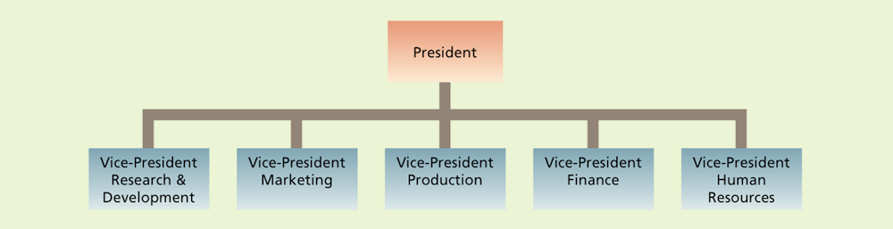

**Product or Market Organization**

* + When departmentalization becomes too complex to coordinate, top management creates semiautonomous divisions.
  + In each division managers and employee design, produce and market their product.
  + The division resembles a separate business and division head is accountable for profit or loss

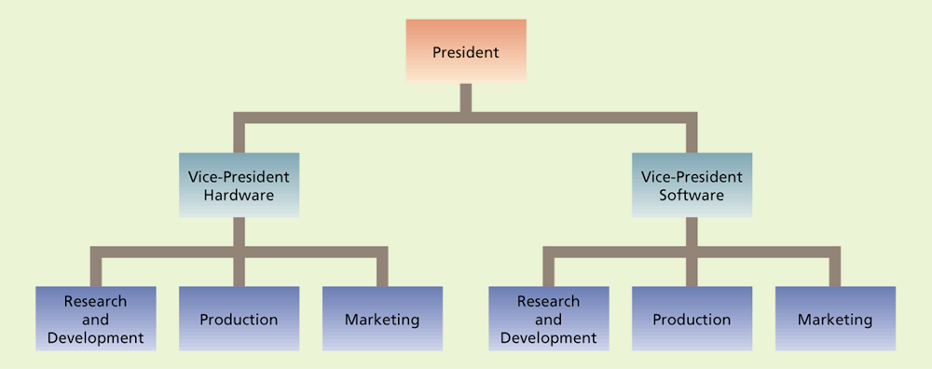

Division based on product

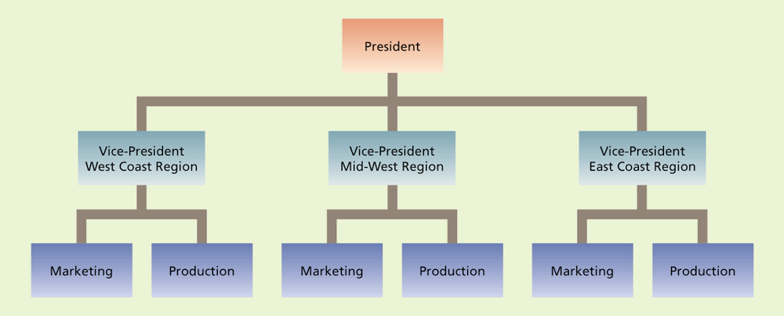

Division based on Geographic area

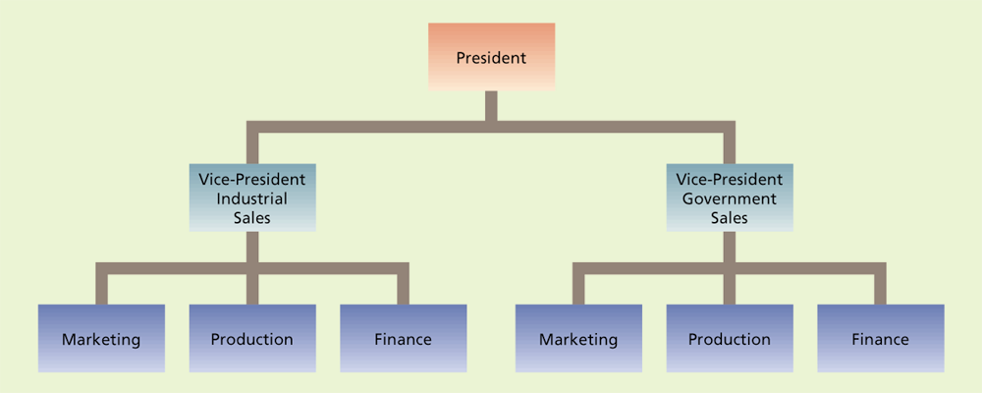

Division based on Customer

**Matrix Organization**

It is also called ‘Multiple command system’ that attempts to combine the benefit of both types of design avoiding their drawbacks. Here employees have to work in two chain of commands. One is functional and diagrammed vertically in span of management. Second is horizontal that combines people from various functional departments into projects or business team (e.g. Construction firm).

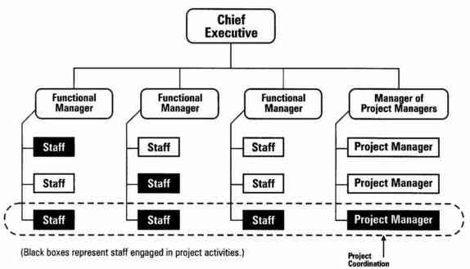

Advantages of Matrix Organization

* + The matrix structure is an efficient means for bringing together the diverse specialized skills required to solve a complex problem.
  + By working together people come to understand the demands faced by those who have different areas of responsibilities
  + It gives the organization a great deal of cost saving flexibility

Disadvantages of Matrix Organization

* + Team members must have good interpersonal skills and be flexible and cooperative.
  + If hierarchies are not firmly established and effectively communicated, conflicting directives and ill-defined responsibilities will tie managers’ hands.