**MOTIVATION**

**What is Motivation?**

* Motivation is a human psychological characteristic that contributes to a person’s degree of commitment.

**Motivation in management**

* Motivating is a management process of influencing other people’s behavior

**Common assumptions about Motivation**

* Motivation is commonly assumed to be a good thing.
* Motivation is in short supply and it need of periodic replenishment
* Motivation is one of several factors that goes into a person’s performance
* Motivation is a tool with which managers can design job relations in an organization

**Early Views of Motivation**

1. **The Traditional model**

* It is associated with Fredrich Taylor. Here manager determine the most efficient way to perform a task and then motivate the worker with a system of wage incentives.
* The underlying assumption is that, managers understand the work better than the worker who are actually lazy and can be motivated only by money.

1. **The Human Relations Model**

* They found that the boredom and repetition of a task actually reduce motivation. While social contacts help to create and sustain motivation.
* The underlying assumption is that, managers can motivate workers by acknowledging their social needs and by making them feel important and useful.

1. **Human Resource Model**

* Associated with Doglas McGregor’s Theory X, Theory Y.
* The underlying assumption is that, in modern industrial life, to take advantage of the employee’s innate willingness and ability to work, managers should provide a climate that gives employee scope for personal improvement.

**Need Theory**

1. **Maslow’s need theory**

Needs that people are needed to satisfy, fall into a hierarchy. Lower level need must be satisfied before higher level need is met.

* Physiological needs - air, food, drink, shelter, warmth, sleep, etc.
* Safety needs - protection from elements, security, order, law, limits, stability, etc.
* Social needs - work group, family, affection, relationships, etc.
* Esteem needs - self-esteem, achievement, mastery, independence, status, dominance, prestige, managerial responsibility, etc.
* Self-Actualization needs - realising personal potential, self-fulfillment, seeking personal growth and peak experiences

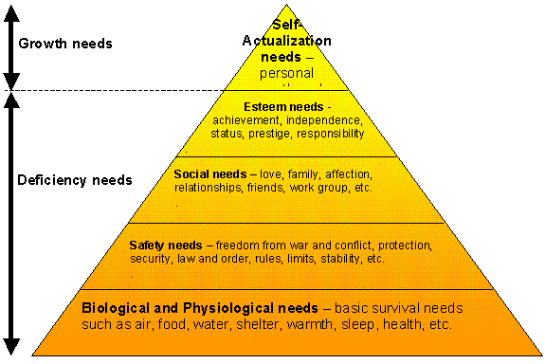

1. **ERG theory**

The letters ERG stand for three levels of needs: **Existence, Relatedness, and Growth.**

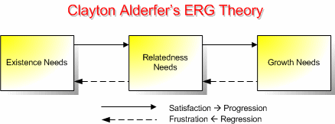

**Similarities to Maslow's Hierarchy**

* + Like Maslow's model, the ERG theory is hierarchical - existence needs have priority over relatedness needs, which have priority over growth.

**Differences from Maslow's Hierarchy**

* + Unlike Maslow's hierarchy, the ERG theory allows for different levels of needs to be pursued simultaneously.
  + The ERG theory allows the order of the needs be different for different people.
  + The ERG theory acknowledges that if a higher level need remains unfulfilled, the person may regress to lower level needs that appear easier to satisfy.

1. **The two factor theory**

Fredrich Herzberg and his associates conducted a study if the job attitude of 200 engineers and accountants.

* + The hygiene factors do little contribution to provide job satisfaction. He called them DISSATISFIERS' as their absence cause dissatisfaction but their presence is not motivating but only prevents dissatisfaction.
  + MOTIVATING factors act as forces of job satisfaction. They create positive and a longer lasting effect on employee’s performance and are related to work itself.

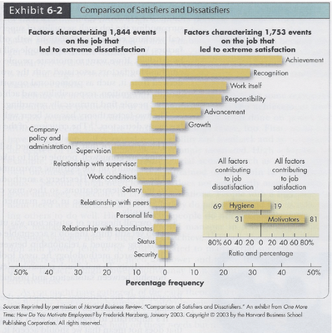

1. **Equity Theory**

* People develop beliefs about what is a fair reward for one’s job contribution - an exchange
* People compare their exchanges with their employer to exchanges with others-insiders and outsiders called **referents**
* If an employee believes his treatment is inequitable, compared to others, he or she will be motivated to do something about it -- that is, seek justice.

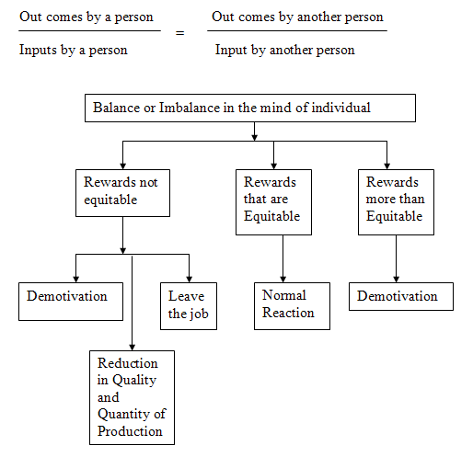

1. **Expectancy Theory**

When deciding among behavioral options, individuals select the option with the greatest motivation forces (MF).

The motivational force for a behavior, action, or task is a function of three distinct perceptions:

MF =  Expectancy  ×  Instrumentality  ×  Valence

* + **Effort performance Expectancy (Expectancy probability):** based on the perceived effort-performance relationship. If I work harder than everyone else in the plant will I produce more?
  + **Performance Outcome Expectancy (Instrumentality probability):** based on the perceived performance-reward relationship. If I produce more than anyone else in the plant, will I get a bigger raise or a faster promotion?
  + **Valence:** Specific outcome has a specific valence that is the power to motivate.

**Intrinsic reward:** eg. Increased self-esteem, satisfaction of developing new skills.

**Extrinsic reward:** eg. Bonuses, Promotions

**Application of Expectancy Theory**

* Determine the reward valued by each employee
* Determine the performance you desire
* Make the performance level attainable
* Link reward to performance
* Analyze what factors might counteract the effectiveness of the reward
* Make sure the reward is adequate

1. **Reinforcement Theory**

Reinforcement theory (given by B.F. Skinner) is the process of shaping behavior by controlling the consequences of the behavior. In reinforcement theory a combination of rewards and/or punishments is used to reinforce desired behavior or extinguish unwanted behavior.

Stimulus

Response

Consequences

Future Response

Consequences of other behavior affect the future actions

1. Positive Reinforcement
2. Avoidance learning
3. Extinction
4. Punishment

**Hamner’s rules for behavior modification**

* Don’t reward all individuals equally
* Be aware that failures to respond can also modify behavior
* Be sure to tell individuals what they can do to get reinforcement
* Be sure to tell individuals what they are doing wrong
* Don’t punish in front of others
* Be fair

1. **Goal Setting Theory**

According to Edwin Locke “ The natural human instinct to set and strive for goals is successful- only if the individual ,both understands and accepts a particular goal. Furthermore .. the worker will not be motivated if they do not possess (and they know it) the skill to achieve that goal.”

Goal setting process:

* Establishment of a standard to be attained
* Evaluation of whether the standard can be achieved
* Evaluation of whether the standard matches personal goals
* The standard is accepted, the goal is thereby set, and behavior proceeds toward the goal