Wage and Incentive plans

**Straight Day-Work**

Under this Scheme, the employer buys the time of the worker.

Earnings E = T × R

T = Time in hours available for work in a day

R = Rate of pay, per hour in Taka

As the specialization began, the management felt that the day work method become less and less applicable because it was very difficult to know the individual qualities and so more difficult to reward for his ability.

**Piece Work**

A uniform rate is paid to the workers for the amount of work performed and not for the time he spends.

Earning E = n × R

n = output in number

R = Piece rate in Taka

**Differential Piece Work**

* **Taylor Differential Piece Work**.

A standard task n1 (units) is carefully established. This standard task is called as “High Task”. First of all, Taylor proposed that the workers producing more than the standard unit will be paid at high rate R2. The worker, who would fail to achieve the standard task, will be paid at low piece rate R1. This Method is named as

Wage/Day

Piece/Day

R2N

R1N

Standard Task / High Task

***(Self study)***

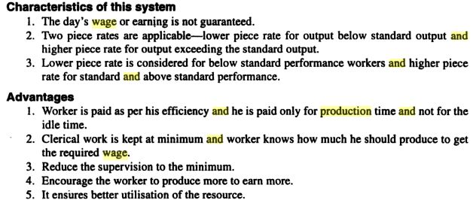

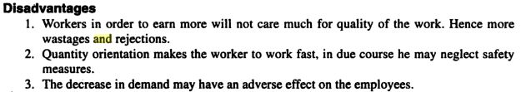

* **Multiple Differential or Merrick Differential Piece Work**

Merrick pointed out that in Taylor System the inferior man cannot survive because of penalty of sub-standard performance. Therefore, Merrick proposed the following changes.

1. That there should not be any penalty on the workers and they should be assured of minimum wages (fair days work = R3)
2. He proposed number of differentials in piece rate e.g.

upto 70% of the standard task …………..Tk R3 (piece rate)

upto 100% of the standard task ………….Tk R4 (increased piece rate)

upto 120% and above the standard task…..Tk R5 (increased rate)

Wage/Day

Piece/Day

R4N

R3

Standard Task / High Task

R5N

70% 100%

Minimum wage Guaranteed

**Halsey Plan:**

Three important characteristics of Halsey plan:

1. Minimum wages are guaranteed
2. There is an additional pay for the output if it is in excess of established standard.
3. It can be applied at all the levels of workers.

Actually Halsey modified the Taylor plan. Major changes are,

1. The standard task is based on recorded experience
2. For output above the task level, the worker is paid a bonus for only a fixed percentage of time saved.
3. The bonus point is set on 60% to 90% of the standard task. This new mark is known as Low Task or Halsey Task.

Wage/Hour

Piece/Hour

Halsey

Guaranteed Wages

Low Task or Halsey Task

If, *R* = Base rate guaranteed on hourly basis

*N* = Total pieces are to be produced

*N2* = Low task in pieces per hour

*T* = Time required for making N pieces

*P* = Percentage of the workers share in gain of above task.

It is generally varying from 25% to 50%

*S* = Standard time for the job on the basis of data = $\frac{N}{N_{2}}$

*(S-T)* = Time saved by the worker

*E =* Wages for the job *= RT + p (S-T) R*

***Example:***

For worker, working in a machine shop, the following data is given. Guaranteed base rate = Tk 25 per hour. Total piece to be produced = 300 pieces. Standard Task= 100 pieces/hour, Low task would be 75% of the standard task. The worker took 2 hours to complete the job. Percentage of the workers’ share in the gain of above task is 40%. Hence calculate the rate of incentive per hour for the worker.

**Solution:** *R* = 25 Tk/hour, *N* = 300, *N2* = 100× 75% = 75, *T* = 2 hours, *p* = 40% = 0.4

*S* = $\frac{300}{75}=4$ hours

Therefore, *E = = RT + p (S-T) R=* 2×25+ 0.4 (4-2) ×25 = 70 Taka

Per hour basis wage = 70/2 = 35 Taka per hour. So, an incentive of (35-25)=10 Taka per hour should be paid.

**Gantt Plan**

Gantt Plan is an improvement over the Taylor's differential piece rate system.

Difference from Taylors plan:

1. Here a minimum wage has been guaranteed, which will protect substandard worker.
2. Wage is on hourly basis, instead of per piece
3. Workers reaching up to output standards, based on scientific time study, will get normal wage rate. Workers, exceeding output standard, are paid at higher wage rate.
4. Standard task is set based on the output level of a good experienced worker.

Gantty

Wage/Hour

Piece/Hour

Guaranteed Wages

Halsey

HighTask or Gantt Task

Low Task or Halsey Task

Fig: Difference from Halsey plan

**Rowan Plan**

Mr. James Rowan proposed that the bonus should be paid on the percentage of time worked rather than time saved. The minimum wage was guaranteed. The wage was calculated as below:

$$E=RT+\frac{\left(S-T\right)}{S}R$$

**Emerson's Efficiency Plan**

Under this plan, incentive is given based on workers efficiency level

Efficiency= (Standard time for the job ) / (Actual time taken to complete the job)

Characteristics:

1. Minimum wages are guaranteed
2. Standard task is based on efficiency level of the worker
3. An incentive is paid if the output level exceed 67% efficiency
4. Bonus increases in proportion with the efficiency level of the worker.

**Group Incentive Plan**

This scheme is suitable, where performance of an individual employee is difficult to measure as he is working in a group to complete the job. The efficiency of the group will be worked out and the incentive amount will be distributed amongst the employees according to their skill / experience level. The scheme is suitable for employees working over assembly lines, bridge building, house building and ship building etc.

Advantages:

1. Better cooperation among workers in the same group
2. Reduction in supervision
3. Reduction in operator training
4. Equal distribution of bonus

**Fringe Benefit**

Any contribution (except regular financial contribution such as bonus, commission, salary) by the employer for the benefit of employees is known as Fringe Benefit. For example, Social security, pension, insurance compensation etc. Although these are not direct incentives but they help to maintain discipline and superior performance.