**IPE 302**

**Experiment 5**

**Mechanism Trainer**

**5.1. Pulley System**

Objective:

1. To study different types of pulley arrangement systems
2. To determine net force acting on an object moving on inclined plane and pulled using pulley system.

Pulley systems are used to provide us with a mechanical advantage, where the amount of input effort is multiplied to exert greater forces on a load.

They are typically used for hauling and lifting loads but can also be used to apply tension within a system such as in a Tensioned Line or Tyrolean.

A person can lift an engine using a hoist (pulley system). Modern cranes can lift enormous loads, for example, lifting oil rigs using combinations of pulleys.

Types of Pulley System

There are a lot of pulley arrangements which involves

1. Simple 1:1 redirecting pulley system
2. 2:1 pulley system
3. 3:1 pulley system
4. 4:1 pulley system
5. 5:1 pulley system … etc.

Figure shows a typical 4:1, 3:1 and 2:1 pulley arrangements respectively

|  |  |  |
| --- | --- | --- |
| C:\Users\Foyel\Desktop\41.JPG | C:\Users\Foyel\Desktop\31.JPG | C:\Users\Foyel\Desktop\21.JPG |
| Mass of load: 10 kg | Mass of load: 10 kg | Mass of load: 10 kg |
| Tension at hand: 10/4 kg | Tension at hand: 10/3 kg | Tension at hand: 10/2 kg |

Assignments:

Determine the net force applied on the object pulled along a slope as shown on the figure.

FN

Fapplied

Ff

Wy

W

Wx

θ

Where,

Fapplied = Force applied on the object by using pulley system

FN = Normal Force

Ff = Frictional Force

W = Weight of the load

θ = angle of the inclined plane

Use the following setup guide for different arrangements:

|  |  |  |  |  |
| --- | --- | --- | --- | --- |
| Pulley system | Load | Slope angle  (degree) | Net force | |
| 25° | 40° |
| 2:1 | 300 | 25 , 40 (floor C & D) |  | |
| 3:1 | 300 | 25 , 40 (floor C & D) |  | |
| 4:1 | 300 | 25 , 40 (floor C & D) |  | |

Formulae for calculation:

$F_{net}=F_{applied}-F_{f}-W_{x}$

$W_{x}=Wsinθ$

$W_{y}=Wcosθ$

$F_{f}=F_{N}μ_{k}$ (Assume, $μ_{k}=0.2$)

Procedure:

1. Setup the sliding plane at required angle using a protractor placing on the steel support (provided for gear arrangements). Observe the pulley arrangements.
2. Consider the winder pulls with a $F_{motor}$ = 1.5 kg force. Calculate *F*applied using pulley tension formulae.
3. Determine Net Force applied ($F_{net}$) with formulae provided above for each arrangement.

**5.2. Gear Mechanism**

Objective:

1. To study different kinds of gear engagement
2. To study the working principle of specific gear arrangements of the lab equipment
3. To determine particular arrangements for required sets of speeds

Types of gear arrangements:

* Simple gear train

A simple gear train uses two gears, which may be of different sizes. If one of these gears is attached to a motor or a crank then it is called the driver gear. The gear that is turned by the driver gear is called the driven gear.

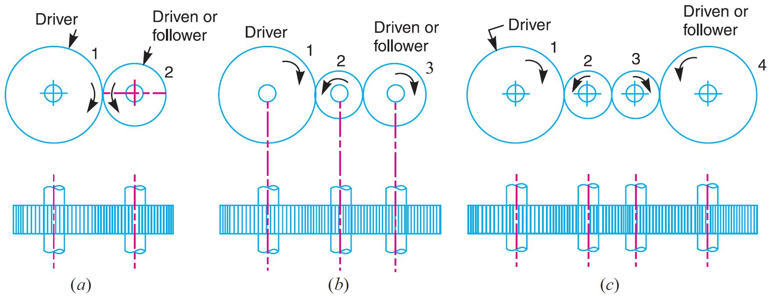

When a simple gear train has three meshed gears, the intermediate gear between the driver gear and the driven gear is called an idler gear (Gear 2 in figure (b)). The number of idler gear can be more than one (figure (c)). The idle gears are used for the following two purposes:

1. To connect gears where a large centre distance is required, and
2. To obtain the desired direction of motion of the driven gear (i.e. clockwise or anticlockwise).

An idler gear does not affect the gear ratio (velocity ratio) between the driver gear and the driven gear.

Since the speed ratio (or velocity ratio) of gear train is the ratio of the speed of the driver to the speed of the driven or follower and ratio of speeds of any pair of gears in mesh is the inverse of their number of teeth

$$Speed ratio=Velocity ratio=Gear ratio=\frac{N_{1}}{N_{2}}=\frac{T_{2}}{T_{1}}$$

It may be noted that ratio of the speed of the driven or follower to the speed of the driver is known as train value of the gear train.

$$Train value=Transmission ratio=\frac{1}{Speed ratio}$$

* Compound gear train

Compound gear trains involve several pairs of meshing gears. They are used where large speed changes are required or to get different outputs moving at different speeds. Whenever the distance between the driver and the driven or follower has to be bridged over by intermediate gears and at the same time a great (or much less) speed ratio is required, then the advantage of intermediate gears is intensified by providing compound gears on intermediate shafts.

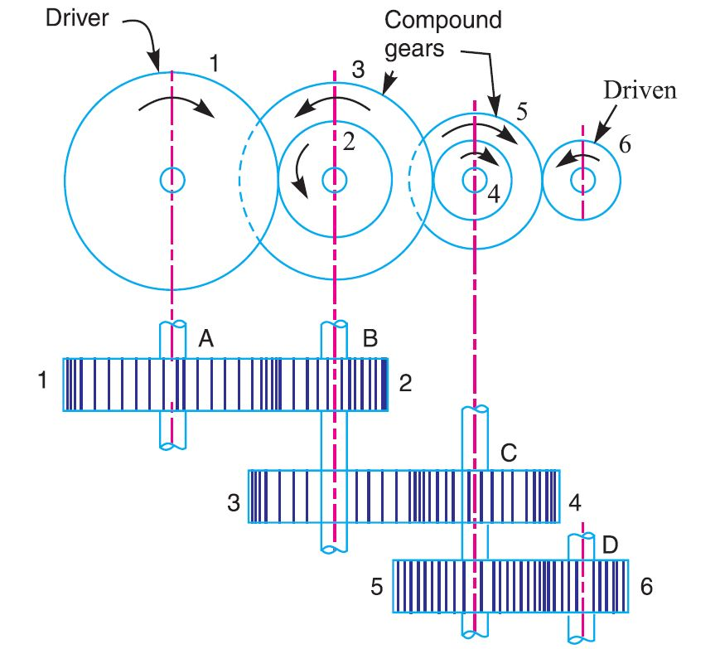

Speed ratio of the gear train =

$\frac{N_{1}}{N_{2}}×\frac{N_{3}}{N_{4}}×\frac{N_{5}}{N_{6}}=\frac{T_{2}}{T_{1}}×\frac{T_{4}}{T_{3}}×\frac{T_{6}}{T_{5}} = \frac{N_{1}}{N_{6}} (since, N_{2}=N_{3} and N_{4}=N_{5})$

Changing axis of rotation using gears

* Bevel Gear

Bevel gears are primarily used to transfer power between intersecting shafts, where the axis of rotation of two shafts are at 90 degrees to each other. But these can be designed to work at other angles as well. The teeth of these gears are formed on a conical surface. There are different types of bevel gears:

**Straight Bevel:** Standard bevel gears have teeth that are cut straight. The teeth point toward the apex of the cone on which they are machined. Standard bevel gears are mainly used in low speed (less than 500 rpm) applications. At high speeds they become noisy. They are typically used in applications such as hand drills.

**Spiral Bevel:** Spiral bevel gears have teeth that have been cut on a curve. The larger surface contact area makes for a smoother, quieter running system, much like helical gears. Spiral bevel gears are typically used for high speed (greater than 500 rpm) and performance applications, where low noise and vibration levels are important. They are typically used in transmission systems.

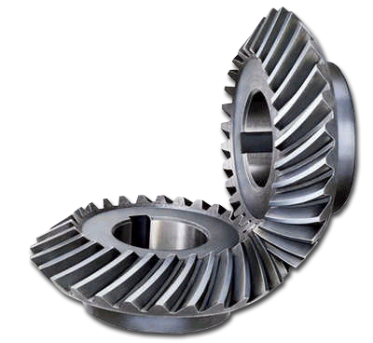

**Hypoid bevel gear:** These are a special type of spiral gear that will allow non-intersecting, non-parallel shafts to mesh. The shape of a hypoid gear is a revolved hyperboloid (that is, the pitch surface of the hypoid gear is a hyperbolic surface), whereas the shape of a spiral bevel gear is normally conical.Hypoid gears are stronger, operate more quietly, and can be used for higher reduction ratios than spiral bevel gears. Hypoid bevel gears are also used in high performance applications, but are more expensive to produce. They are typically used in transmission systems.

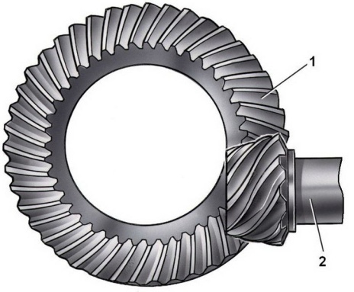 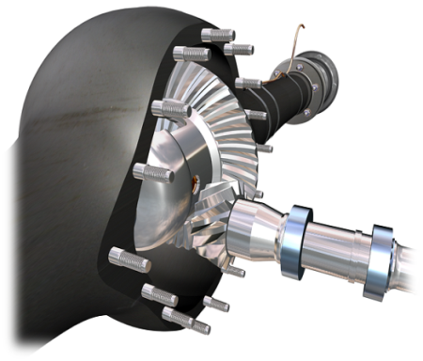

* Worm Gear

Worm Gear is a [gear arrangement](https://en.wikipedia.org/wiki/Gear) system in which a worm (which is a gear in the form of a [screw](https://en.wikipedia.org/wiki/Screw_thread)) meshes with a worm gear (which is similar in appearance to a [spur gear](https://en.wikipedia.org/wiki/Gear#Spur) or helical gear, and is also called a worm wheel). They allow two non-intersecting shafts at right angles to mesh with each other. Worm drives provide a large reduction in speed. For one rotation of the worm gear, the gear wheel moves by a distance of one tooth. They are typically used in gearboxes, where large reductions in speed, for example 300:1, are required.

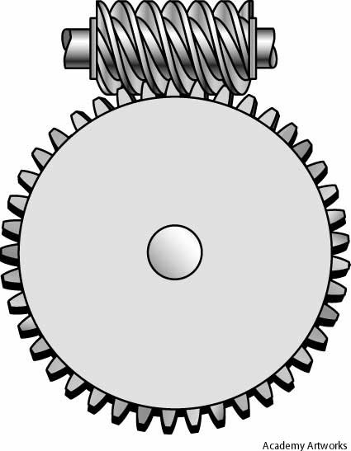

* Rack and Pinion Gear

The rack-and-pinion is typically used to turn rotary motion into linear (straight line) motion, or vice versa. A circular gear (usually spur gear) called "the [pinion](https://en.wikipedia.org/wiki/Pinion)" engages teeth on a linear "gear" bar called "the rack"; [rotational](https://en.wikipedia.org/wiki/Rotation) motion applied to the pinion causes the rack to move. The rack-and-pinion is typically used in automotive steering systems.

Assignment:

Determine the following speeds for corresponding gear arrangement type specified (all starting from Motor rotation) using different combination of gears:

|  |  |  |  |  |  |
| --- | --- | --- | --- | --- | --- |
| Case | Type of gear train to be used | End component | Required Speed | Actual speed | Efficiency  % |
| 1 | Simple gear train | Winder | 30 |  |  |
| 2 | Compound gear train using two double cluster gears | Winder | 12.5 |  |  |
| 3 | Bevel gear system | Second gear after bevel system | 19 |  |  |

Procedure:

1. Using the formulae explained earlier in the experiment, determine the set of gears required to get the specified speeds.
2. Set the gears as obtained from the calculation.
3. Determine the actual output speed at the end component using tachometer.
4. Calculate the efficiency of the each gear system.

**5.3. Cam Mechanism**

Theory

The transformation of one of the simple motions, such as rotation, into any other motions is often conveniently accomplished by means of a cam mechanism. A cam mechanism usually consists of two moving elements, the cam and the follower, mounted on a fixed frame .A cam is a machine component that either rotates or moves back and forth (reciprocates) to create a prescribed motion in a contacting element, known as a follower. The shape of the contacting surface of the cam is determined by the prescribed motion and the profile of the follower .   
Cam-follower mechanisms are particularly useful when a simple motion of one part of a machine is to be converted to a more complicated prescribed motion of another part, one that must be accurately timed with respect to the simple motion and may include periods of rest (dwells). Cams are essential elements in automatic machine tools, textile machinery, sewing machines, printing machines, gear-cutting machines, screw machines and many others. If the follower is not restrained by a groove on the cam, a spring is necessary to keep the follower in contact with the cam.

Cam Nomenclature

* 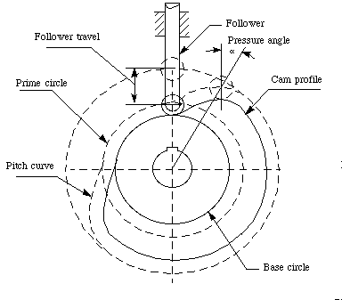Trace point: A theoretical point on the follower, corresponding to the point of a fictitious knife-edge follower. It is used to generate the pitch curve. In the case of a roller follower, the trace point is at the center of the roller.
* Pitch curve: The path generated by the trace point at the follower is rotated about a stationary cam.
* Working curve: The working surface of a cam in contact with the follower. For the knife-edge follower of the plate cam, the pitch curve and the working curves coincide. In a close or grooved cam there is an inner profile and an outer working curve.
* Pitch circle: A circle from the cam center through the pitch point. The pitch circle radius is used to calculate a cam of minimum size for a given pressure angle.
* Prime circle (reference circle): The smallest circle from the cam center through the pitch curve.
* Base circle: The smallest circle from the cam center through the cam profile curve.
* Stroke or throw: The greatest distance or angle through which the follower moves or rotates.
* Follower displacement: The position of the follower from a specific zero or rest position (usually it is the position when the follower contacts with the base circle of the cam) in relation to time or the rotary angle of the cam.
* Pressure angle: The angle at any point between the normal to the pitch curve and the instantaneous direction of the follower motion. This angle is important in cam design because it represents the steepness of the cam profile.

Types

Cam is used in almost all types of automatic and semi automatic machines .Generally it can be of 3 types

* **Plate type cam** – Disk type eccentric cam

Disk type with desired peripheral profile

Flat/linear plate cam

Lobe cam

* **Cylindrical/Barrel cam** - it is used to obtain linear motion, parallel to the cam axis . For e.g. - in single spindle automatic lathe ,it is used for radial feeding of tool
* **Wedge cam** - it is like a taper rod or plate. It imparts an oscillatory motion to the follower which is synchronized with other tool-work motion .for eg- the relieving motion of the cutter (or the blank) in the gear shaping machine

Cam followers

Cams followers can be either reciprocating or pivoting.   There are various methods of transferring the motion from the cam to the follower including the following:

* 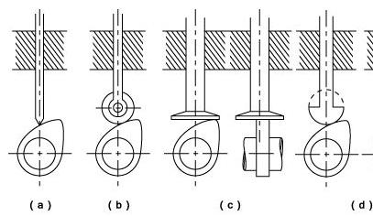Knife Edge
* Roller
* Flat-face
* Curved-shoe /spherical

Fig 1

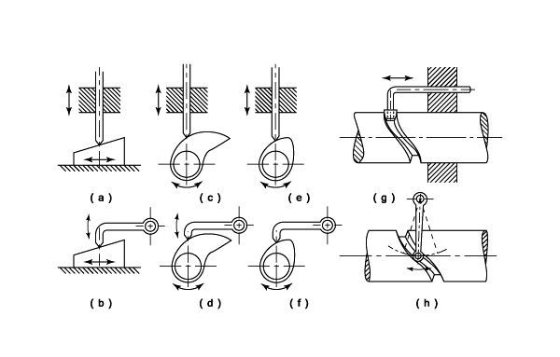

Fig 2

**Fig 1-** Shows different types of cam follower.

**Fig 2-** Shows different types of cams which are imparting different types of motion to the follower.

Design of a Cam System

The first stage in designing a cam system is the creation of a displacement diagram. A typical plate cam with an in-line flat follower is shown below with a displacement diagram. This figure shows the following characteristic features.

* The rise- This is when the follower is moving away from the cam centre. The slope reflects the follower velocity
* The dwell- the is the period when the follower is stationary
* The return - This is when the follower moves back towards the cam centre
* The base circle on the cam is the smallest full diameter of the cam
* The prime circle is centered on the cam rotation centre with radius at the follower roller centre when the follower is on the base circle
* The cam profile is the shaped surface of the cam defining the follower motion

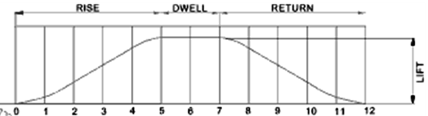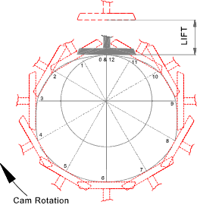

Fig 4: Displacement diagram and Cam profile

3 Design Examples

1. Design of cam with knife-edge follower and uniform velocity*

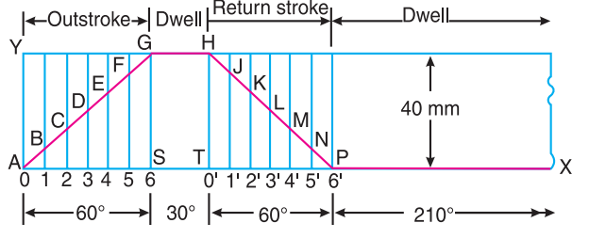

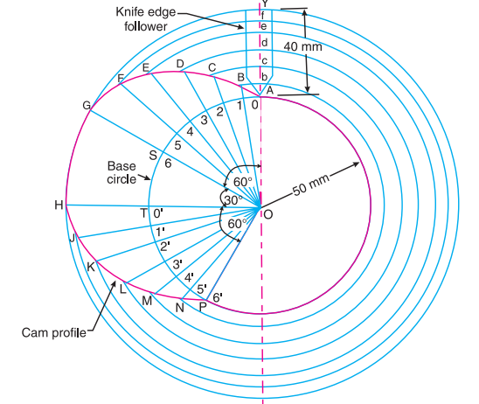

1. Design of cam with flat follower and simple harmonic motion*

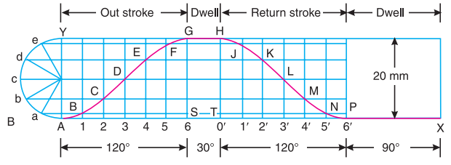

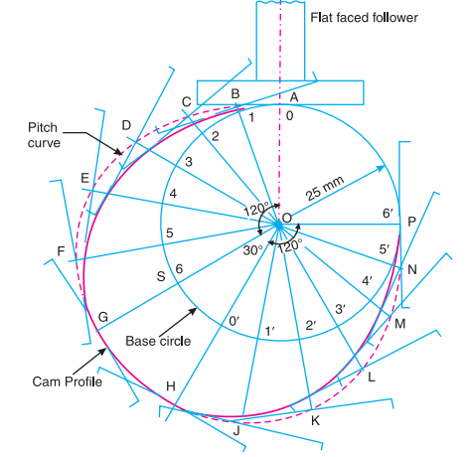

1. Design of cam with roller follower and uniform speed*

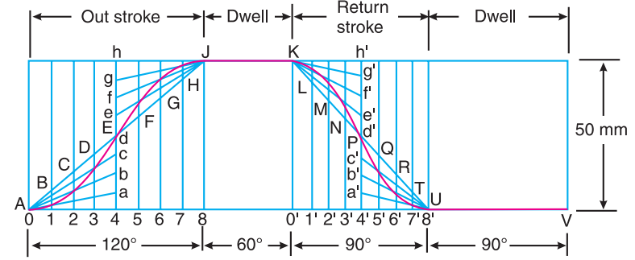

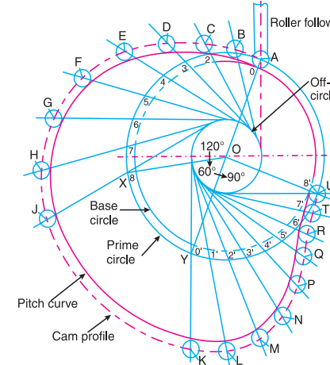

* * If an object covers equal distance in equal intervals of time, we can say that the object is moving with a **uniform speed**. A body is said to move with **uniform velocity** if it has no acceleration, i.e. the body moves with a constant speed along a **straight line path**. Where a **simple harmonic motion** is a type of periodic motion where the restoring force is directly proportional to the displacement

Procedures

1. Transmit rotation to the cam by using appropriate gear train. Find the rate of actuation (ω) and maximum stroke length of the follower due to the cam rotation by using stop watch and scale.
2. 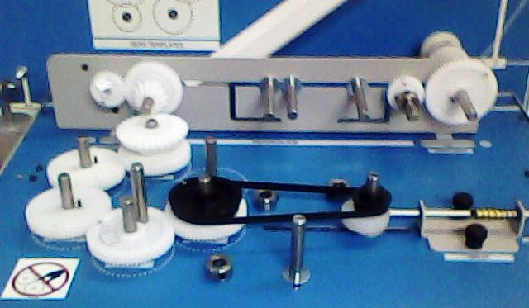Calculate maximum velocity during follower ascend (out stroke) and descend (return stroke).

Hint:

$v_{o}$ = $\frac{2S}{t_{o}}$ = $\frac{2ωS}{θ_{o}}$

$v_{r}$ = $\frac{2S}{t_{r}}$ = $\frac{2ωS}{θ_{r}}$

Here, $v_{o}$, $v_{r}$ = maximum velocity during follower out stroke or return stroke

S= stroke length of the follower

ω = angular velocity of the cam (rate of actuation)

$t_{o}$, $t_{r}$ = time required for out stroke or return stroke

$θ_{o}$, $θ_{r}$ = angular displacement (in radian) of the cam during out stroke or return stroke. (Assume $θ_{o}$ = 115 degree, $θ_{r}$ = 120 degree)

**Assignments:**

1. Draw a 12 position displacement diagram for the uniform speed motion of the cam used in the experiment. Now for that displacement diagram, draw a cam profile with roller follower. Assume roller dia to be 8 mm. Take maximum stroke of the follower and minimum radius (base circle radius) of the cam as obtained from the experiment.
2. Design a cam with roller follower (roller dia. =10 mm) which moves in simple harmonic motion and has... Out stroke =50/55/60/65/70/75 degree

Dwell = 50 degree

Return stroke = 70/65/60/55/50/45 degree

And dwell for the rest.

Maximum stroke of the follower is 40 mm and minimum radius 50 mm.