No. of Experiment: 03
Name of Experiment: Study of TIG, MIG, Resistance welding and Gas welding

Tungsten Inert Gas (TIG) Welding:

It i s also known as Gas-Tungsten Arc welding (GTAW). It is an arc welding process wherein coalescence is produced by heating the job with an electric arc struck between a tungsten electrode and the job. A shielding gas (argon, helium, nitrogen, etc.) is used to avoid atmospheric contamination of the molten weld pool. A filler metal may be added, if required.
Equipment:
1. Welding Torch, Tungsten electrode and filler metal.
2. Welding power source? high frequency unit, DC suppressor unit and cables.
3. Inert gas cylinder, pressure regulator and flow meter.
4. Cooling water supply.
5. Water and gas solenoid valves.
Base Metals Welded:
1. Carbon and alloy steels
2. Stainless steels
3. Heat resisting alloys
4. Refractory metals
5. Aluminum alloys
6. Copper alloys
7. Magnesium alloys
8. Nickel alloys, etc.

Joint Design:
Butt, Lap, Comer, Edge and T joint- are all used in TIG welding.

Principle of Operation :
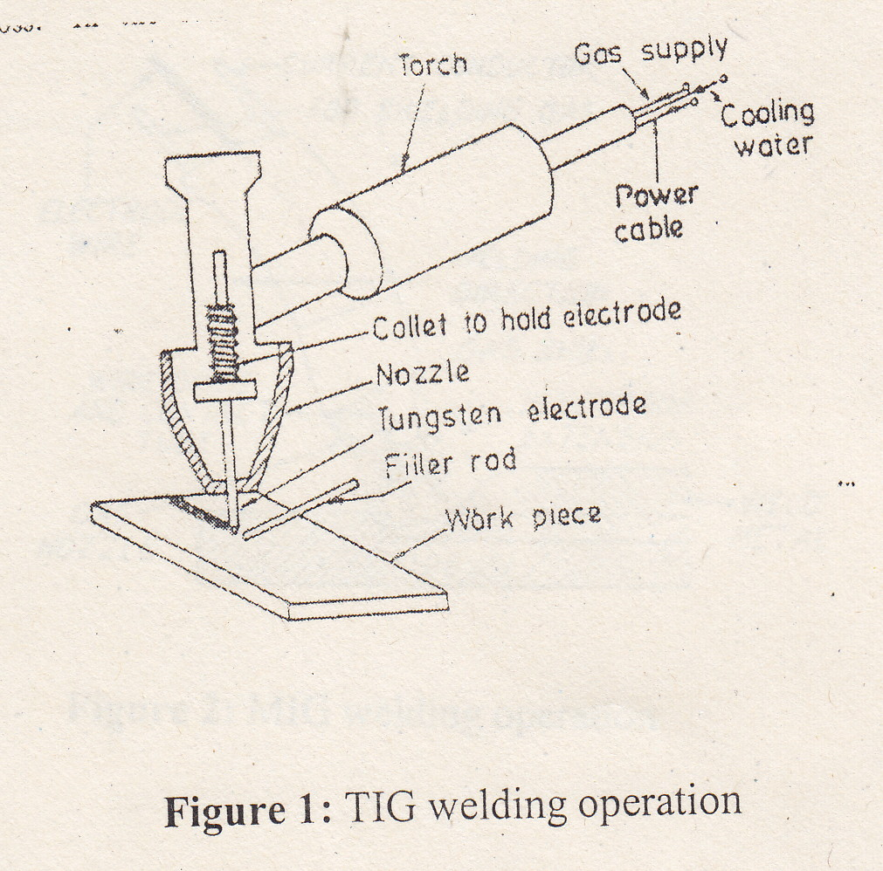

Welding current, water and inert gas supply are turned on. The arc is struck either by touching the electrode with a scrap metal or using a high frequency unit. In the first method, arc is initially struck on a scrap metal piece (or a tungsten piece) and then broken by increasing the arc length. This procedure repeated twice or thrice warms up the tungsten electrode. The arc is then struck between the electrode and pre-cleaned job.

Metal Inert Gas (MIG) Welding:
It is also known as Gas Metal Arc welding (GMAW). Like TIG, It is also an arc welding process wherein coalescence is produced by heating the job with an electric arc established between a continuously fed metal electrode and the job. No flux is used but the arc and molten metal are shielding by an inert gas (argon, helium, nitrogen, etc.).

Equipment:
1. Welding power source and cables.
2. Welding torch and wire electrode coiled on a spool.
3. Wire feed mechanism and controls consisting of a pair of driving rolls, electric
motor, etc.
4. Shielding gas cylinder, pressure regulator and flow meter.

Base Metals Welded:
1. Carbon and low alloy steels
2. Stainless steels
3. Heat resisting alloys
4. Refractory metals
5. Aluminum and its alloys
6. Copper alloys (other than high zinc alloys), and
7. Magnesium alloys.
Joint Design:
Butt, Lap, Corner, Edge and T joint- are all used in MIG welding.

Principle of Operation:

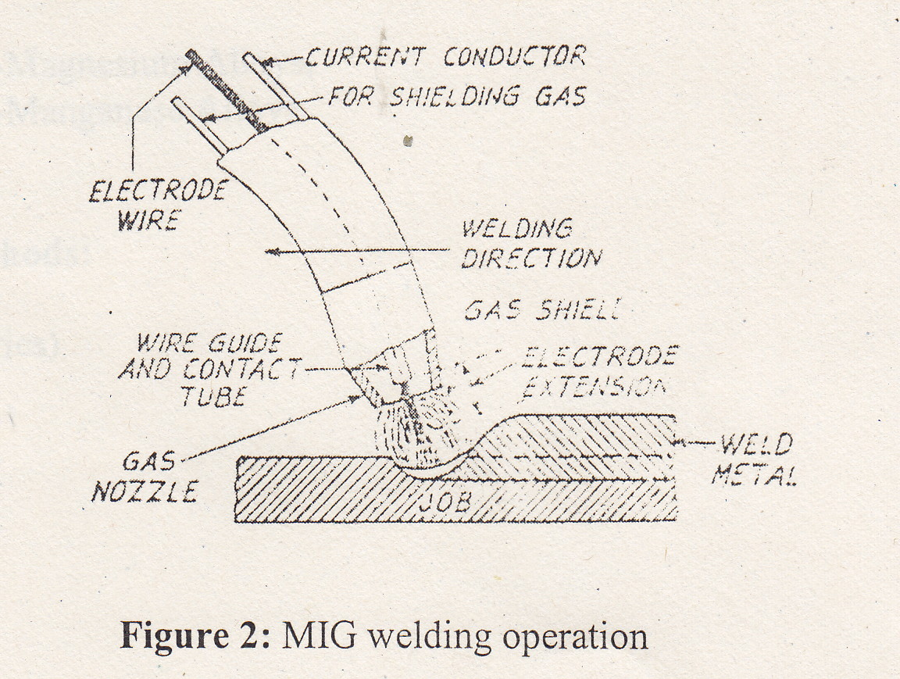

Resistance (Spot)Welding:
Resistance welding is a group of welding processes wherein coalescence is produced by the heat obtained from resistance of the work to the flow of electric current in a of which the work id a part and by the application of pressure. No filler metal is needed. Spot welding is a resistance welding process in which overlapping sheets are joined by local fusion at one or more spots.

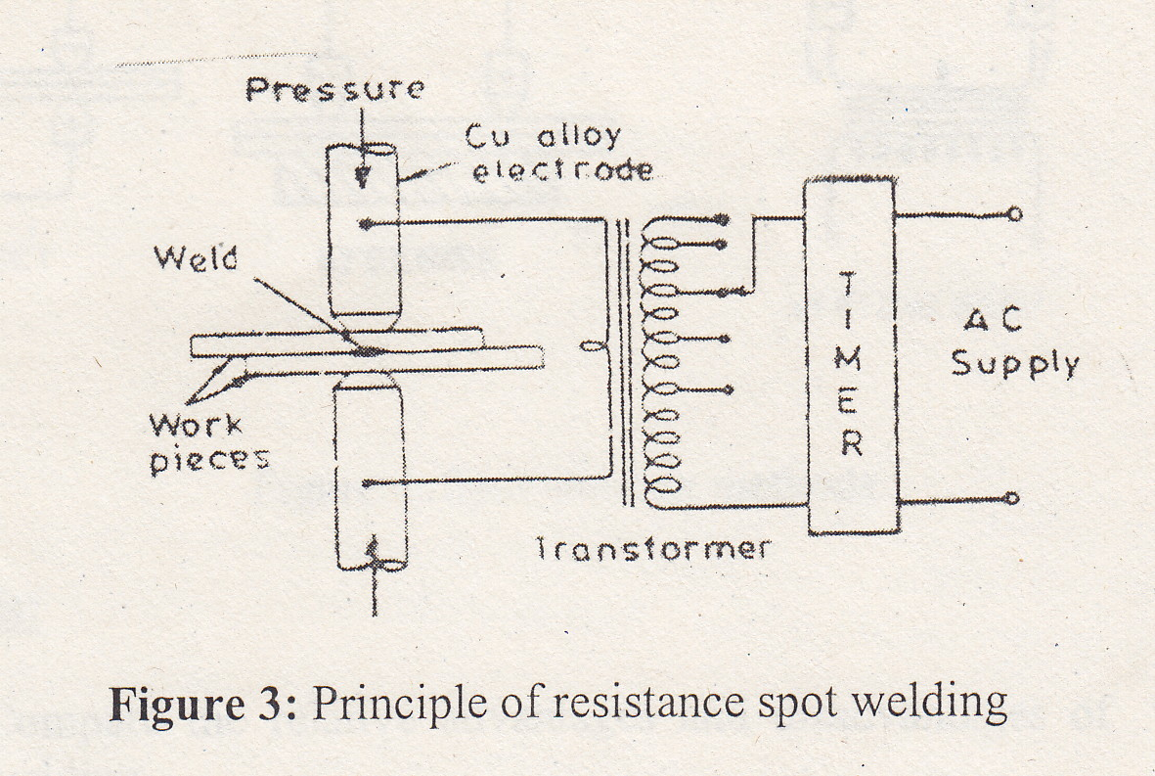

Spot Weldable Metals:
(a). Ferrous Metals:
I. Low carbon steel (mild steel),
II. High speed steel
III. Stainless steels
IV, Coated steels

(b). Non-ferrous Metals:
I. Aluminium,
II. Aluminium-Magnesium Alloys,
IlI. Aluminium-Manganese Alloys.

Gas welding:
In oxyacetylene welding or gas welding, the two gases used for producing flame are. oxygen) and acetylene. Oxygen is used to support and intensify combustion Much oxyacetylene gas welding is done manually. Gas coming from either the acetylene or oxygen tank is first reduced in pressure through a regulator. This is a diaphragm operated valve that can be adjusted to let only enough gas out of the tank to maintain a desired pressure on the outlet side. Gages on each regulator shows the tank and the hose pressures.

Hoses conduct the gases to the torch or blowpipe held by operator. The torch mixes the two gases properly and emits them into the flame. It consists basically of regulating valves, body, mixing head and a tip. A number of sizes of tips are available to give different sizes and intensities of flames for various purposes.

Flame: This is the phenomenon produced at the surface of the nozzle tip where two gases meet and undergo combustion with the evolution of heat and some light. The chemical reaction for complete combustion of oxygen and acetylene is as follows -

2C₂H₂ + 5O₂ = 4CO₂ + 2H₂O

Thus for complete combustion, ratio of oxygen to acetylene is 2.5 to 1. The temperature of flame is dependent upon the relative proportion of the two gases.
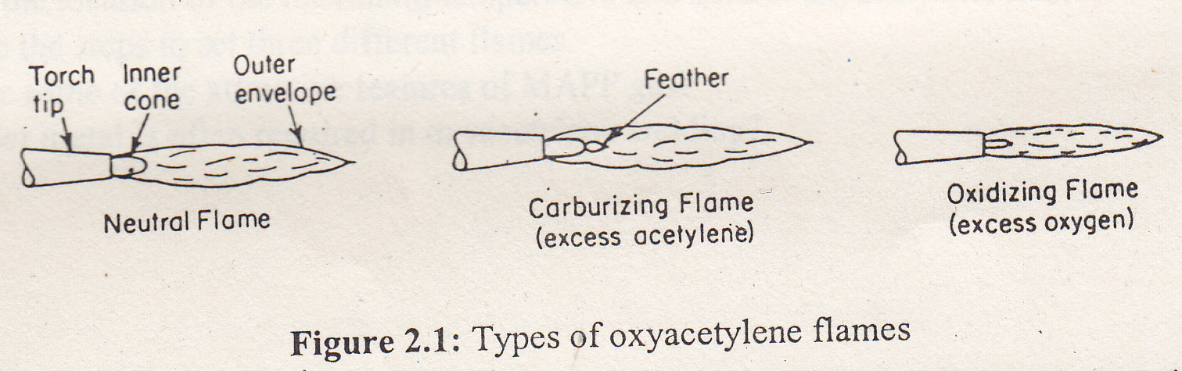
l. Neutral/natural flame: The natural flame has no tendency to react with materials being welded. The highest temperature is at the tip of the inner cone and is capable of melting all commercial metals and many refractories.
2. Reducing/carburizing flame: The carburizing flame is distinguished by a redish feather at the tip of the inner cone. It is capable of reducing oxides.
3. Oxidizing flame: An oxidizing flame assures complete combustion and the highest temperature but has a strong tendency to oxidize metals being welded which may be detrimental.
Actually, heating is done with the inner cone and the envelope of a flame shields and protects the weld zone from the atmosphere.

Advantages of Gas welding: The oxyacetylene flame can be easily controlled. Because it is not as piercing as are welding, it is generally more suitable for thin sheets. The equipment is portable. So gas welding can be easily done outdoors and for repair work. By changing the nozzle, torch can be used f or heating, welding, brazing and cutting purpose.

Limitations of Gas Welding: It is slower than arc welding. Heat affected zone and distortions are more compared to arc welding. Gases are expensive and there may be safety problems in storing and handling the gases.

Equipment :
i. Welding torch or blowpipe
ii. Pressure regulator
iii. Hoses and fittings
iv. Cylinders
v. Goggles
vi. Spark lighters
vii. Apron
viii. Gloves
ix. Welding rods
x. Flux etc.

PROCEDURE:
i. welding, gas cutting and brazing by changing the rate of flow of gases.
ii. Set different types of flames.
iii. Note the pressure of the gases from the pressure gages.
iv. Submit the work done to the teacher.

Assignment:
- Compare the relative advantages and disadvantages of TIG and MIG welding.
- Describe the fundamental principles of resistance welding.
- Identify the limitations of resistance welding.
- Compare TIG and MIG with shielded metal arc welding.
- What is the location of the maximum temperature in a natural oxyacetylene flame?
- Describe the steps to set three different flames.
- Why filler metal is often required in oxyacetylene welding?

